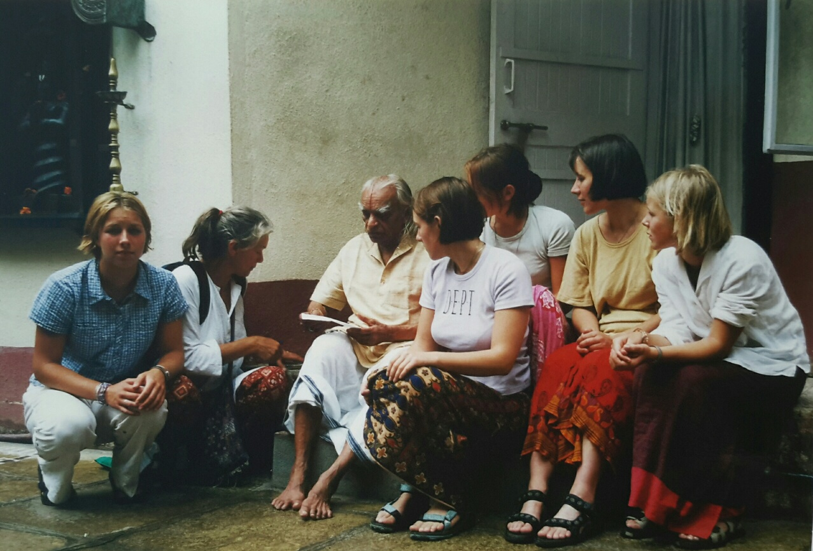

Pune 2001 Together with my daughters visiting Guruji to ask him traveling advise.

He advises us to contact Savita in Bangalore. Although I was a bit embarrassed I did contact her and together with Savita we visited all beautiful temples and places in Bangalore. We had a fantastic trip and also visited Mysore , Haridwar, Somnathpur, and all special and beautiful places. Of course we also visited a very poor Bellur and Guruji’s piece of land, then still full with mango and coconut trees.

It was about the same trip of seven years later, on the occasion of Guruji’s 90th birthday. This time Bellur completely transformed, thanks to Guruji.

Both trips were an unforgettable experience.